Title: Kawasaki Disease Final Project Report
By: Alyshondria Hicks
For: Predictive Modeling & Analytics 566
Date: Th 12/11/25
Assignment: Final Project

Project Description
Kawasaki Disease (KD), also known as mucocutaneous lymph node syndrome, is an acute, self-limited inflammatory vasculitis that predominantly affects children under five years of age, although the underlying etiology remains unknown. Clinically, KD is characterized by persistent fever, mucocutaneous inflammation, and widespread vasculitis affecting medium-sized arteries. Without timely intervention, the disease can lead to severe cardiovascular complications, most notably coronary artery dilation and aneurysm formation. Despite substantial advances in clinical management, predicting disease severity, treatment response, and long-term outcomes remains difficult due to the heterogeneity of patient presentations and the absence of definitive biomarkers[1]. These challenges highlight the need for more advanced, data-driven approaches capable of extracting clinically relevant patterns from complex and multidimensional patient data.
Machine learning (ML) techniques offer a powerful framework for modeling this complexity. In particular, dimensionality reduction methods—such as Principal Component Analysis (PCA) or other feature-compression techniques—enable the transformation of high-dimensional clinical datasets into more compact, noise-reduced representations while preserving the majority of meaningful variance. This step not only improves computational efficiency but can also enhance model interpretability and mitigate overfitting. Building upon these reduced-dimension feature sets, deep learning architectures such as feedforward neural networks (FNNs) are well-suited for learning nonlinear relationships that may underlie KD progression and clinical outcomes [2]. By combining dimensionality reduction with neural network–based predictive modeling, this project aims to develop a more robust and scalable framework for forecasting critical clinical endpoints in Kawasaki Disease—including the likelihood of coronary artery involvement and potential resistance to intravenous immunoglobulin therapy. Ultimately, this integrated ML approach seeks to support earlier, more personalized, and more effective clinical decision-making for children affected by KD.
Data Description
This dataset, obtained from the Kaggle repository, contains 2,752 patient records and 15 distinct features organized into four primary domains. The demographic information includes patient ID, date of diagnosis, age at diagnosis, gender, ethnicity, and geographic location. Clinical characteristics encompass fever duration, presenting symptoms, laboratory test results, and echocardiographic findings. The dataset also includes key treatment variables, such as the initial therapeutic approach administered. Finally, outcome and prognostic indicators capture clinical outcomes, documented complications, follow-up visits, and long-term health effects [3]. Together, this structured dataset provides a comprehensive foundation for examining how demographic, clinical, and treatment-related factors influence patient trajectories and prognostic trends in Kawasaki Disease. This data can be accessed at: https://www.kaggle.com/datasets/cm037divya/kawasaki-dataset.
Methods and Analysis
The machine learning strategies employed in this project included dimensionality reduction and a deep learning feedforward neural network. Following one-hot encoding of categorical variables, the dataset expanded to 45 total features, motivating the use of Principal Component Analysis (PCA) to mitigate redundancy and reduce noise within the feature space. PCA evaluation indicated that 38 principal components were sufficient to retain more than 92% of the dataset’s total variance, providing a compact yet information-rich representation of the underlying clinical, demographic, and laboratory patterns. This reduced-dimensionality input served as the foundation for subsequent neural network modeling, enabling more efficient training and improved generalization performance.
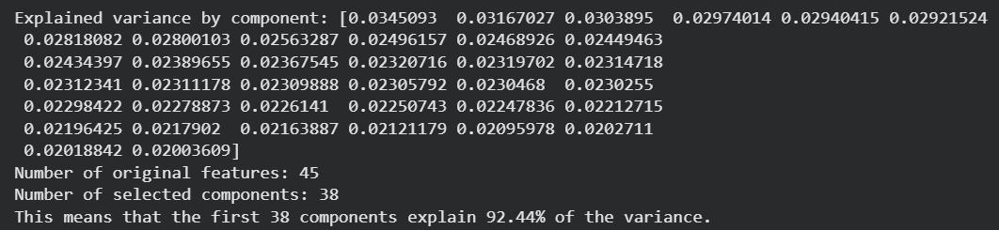
Figure 1: Principal Component Breakdown & Variability Calculation

Prior to model development, feature selection procedures were applied to remove low-information variables, followed by standardization of the feature space and an 80/20 stratified split into training and testing subsets. A feedforward neural network (FNN) was subsequently implemented to evaluate whether a deep learning approach could outperform the previously tested classical machine learning algorithms. Model evaluation on the held-out test set yielded accuracy, F1-score, recall, and precision values ranging from approximately 37% to 42%, indicating modest predictive performance and highlighting the inherent difficulty of distinguishing clinical outcome categories within this dataset.

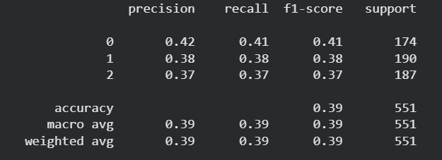
Figure 2: FNN Classification Report
Evaluation

The model frequently defaults to predicting the stable category when uncertainty is high, likely due to substantial latent clinical similarity across the patient groups. This tendency is particularly evident in its difficulty identifying the improvement class, which is often misclassified as either stable or worsening, indicating considerable feature-level ambiguity between these outcomes. While the stable class is predicted with the highest accuracy, its 117 misclassifications demonstrate substantial overlap with both improvement and worsening trajectories. Moreover, the most severe worsening cases are not distinctly separable from stable or mildly improving states within the available feature space. These findings suggest that a single timepoint clinical snapshot is insufficient for distinguishing early or subtle deterioration, reinforcing the need for longitudinal or trend-based features to more accurately track disease progression.

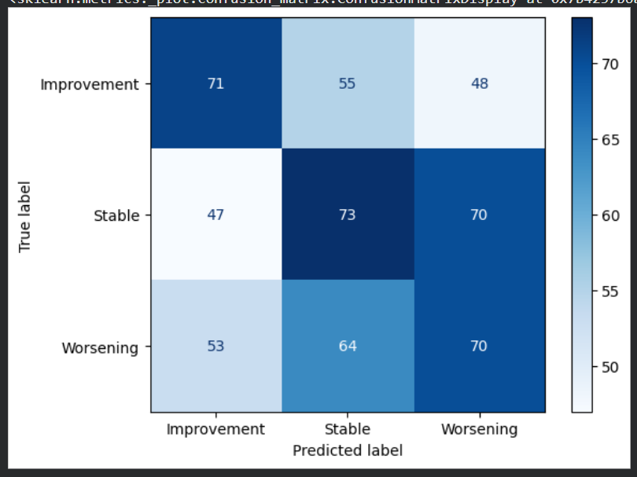
Figure 3: FNN Confusion Matrix

Overall, the current feature set provides limited separability among the KD severity categories, indicating that the available clinical and laboratory variables do not strongly discriminate between outcome groups. Many of the laboratory values and clinical markers exhibit only subtle or nonlinear fluctuations across patients, making them difficult to model effectively using standard tabular features. Future work should incorporate temporal dynamics, such as changes in fever duration, serial laboratory trends, and time-indexed symptom progression, as these longitudinal features are often more informative than single time-point measurements. Additionally, constructing derived metrics—including laboratory ratios, delta changes, and normalized severity indices—may help capture clinically meaningful variation. Beyond feature engineering, adopting architectures tailored to disease progression, such as recurrent or temporal deep learning models, could further enhance the ability to characterize KD trajectories and improve prediction of clinical outcomes.

References

- ChatGPT
- Dr. Khairi’s Notes
- Kaggle.com

